# Personal Portfolio – Mitchell Sainty

## Artefact 1 – Updated the user stories

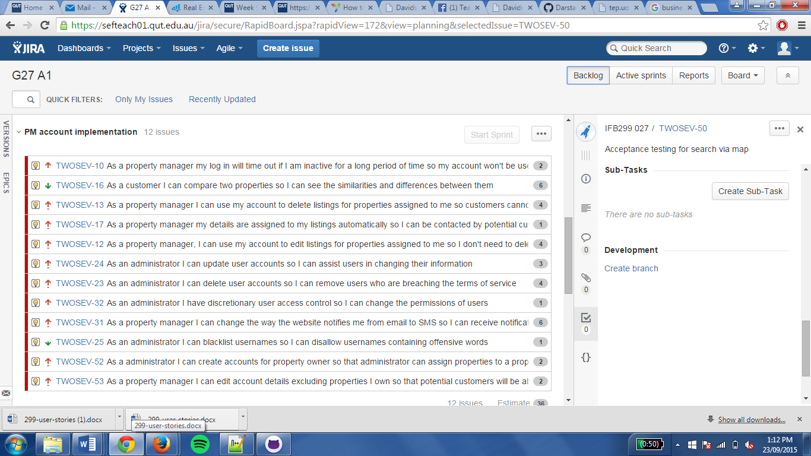

We updated the user stories after the first sprint, to ensure that they better represented what needed to be completed. Most importantly, we more accurately updated the story points to better represent the difficulty and the amount of time required to complete each user story. The user stories were also fleshed out into more detail, especially in the description of each in Jira

## Artefact 2 – Created CRUD for tenants

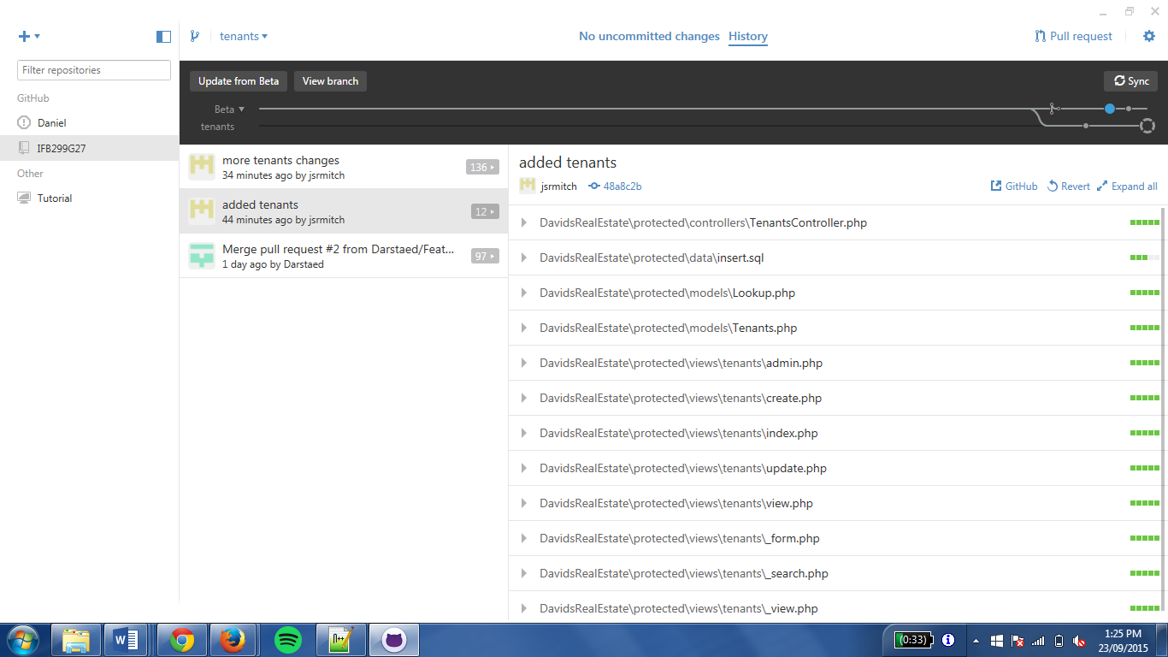

Create, read, update and delete functions were added for tenants. Therefore, tenants can add their information before adding property listings to the website.

## Artefact 3 – Created User Menu Portlet

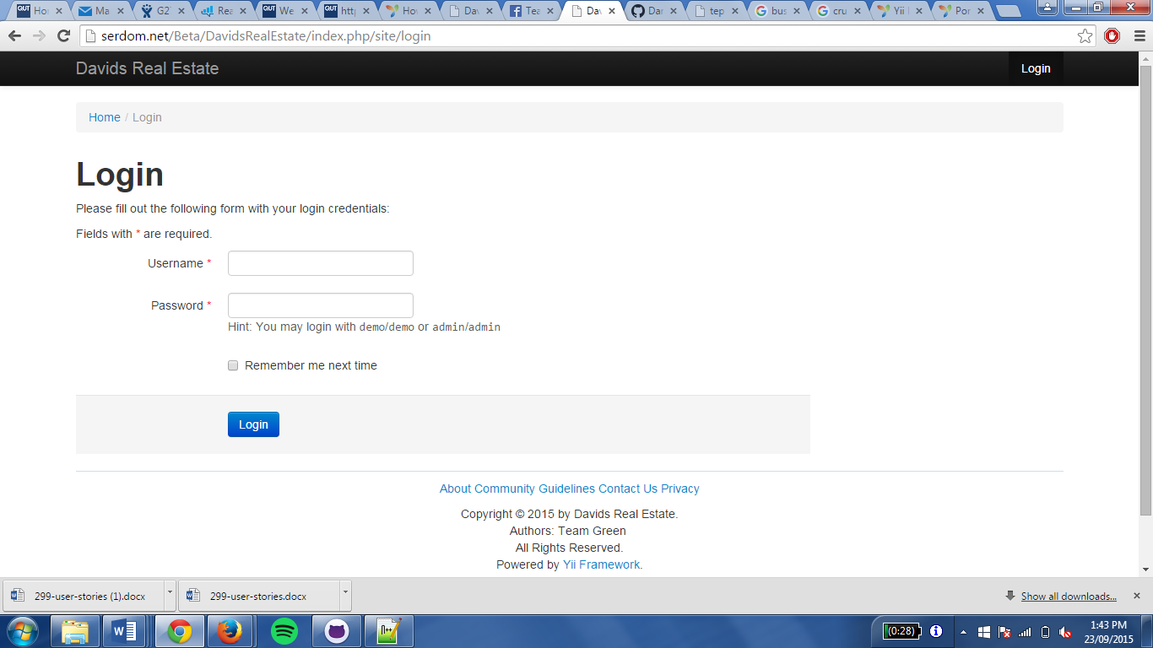

The user menu portlet displays a list of menu items that are only available to authenticated users. This includes:

* Create Property Listings: a hyperlink that leads to the post creation page;
* Manage Property Listings: only available to administration
* Logout: a link button that would log out the current user.

## Artefact 4 – Created Database

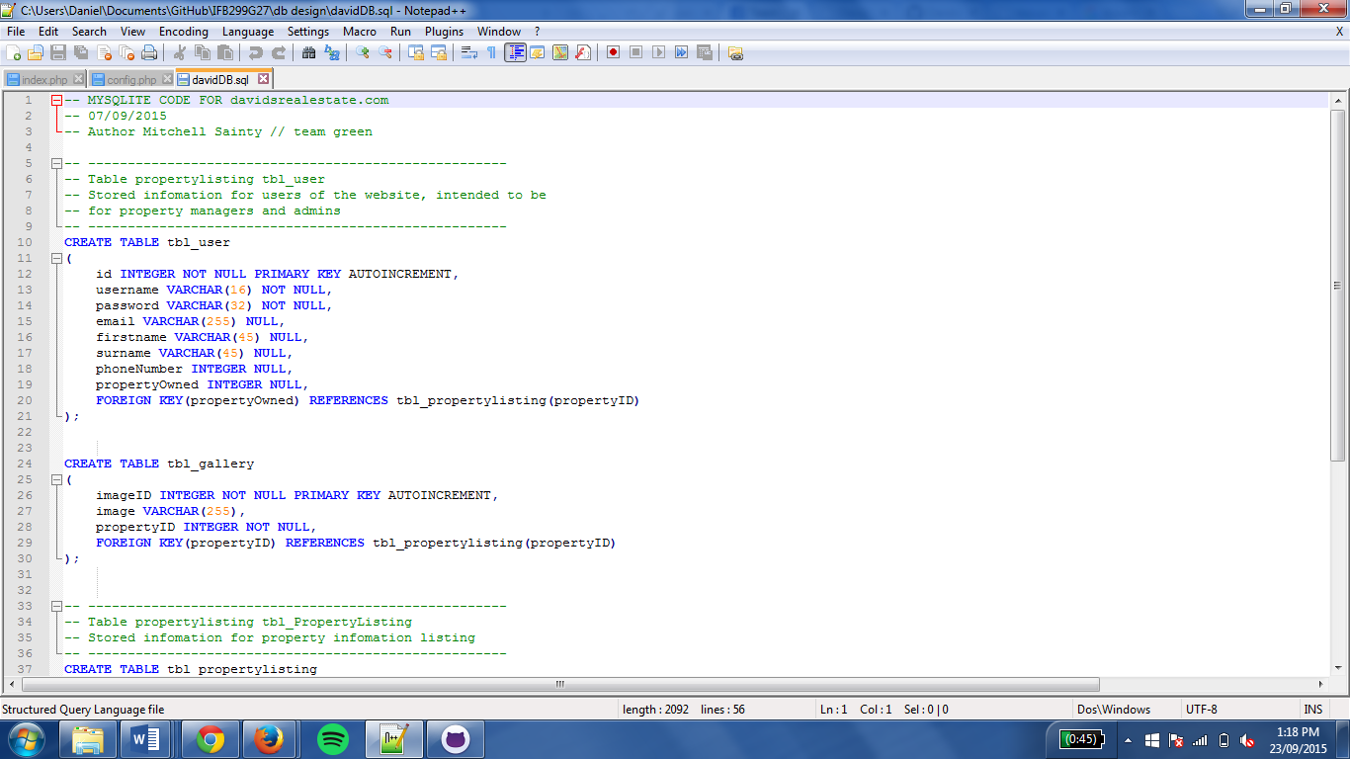

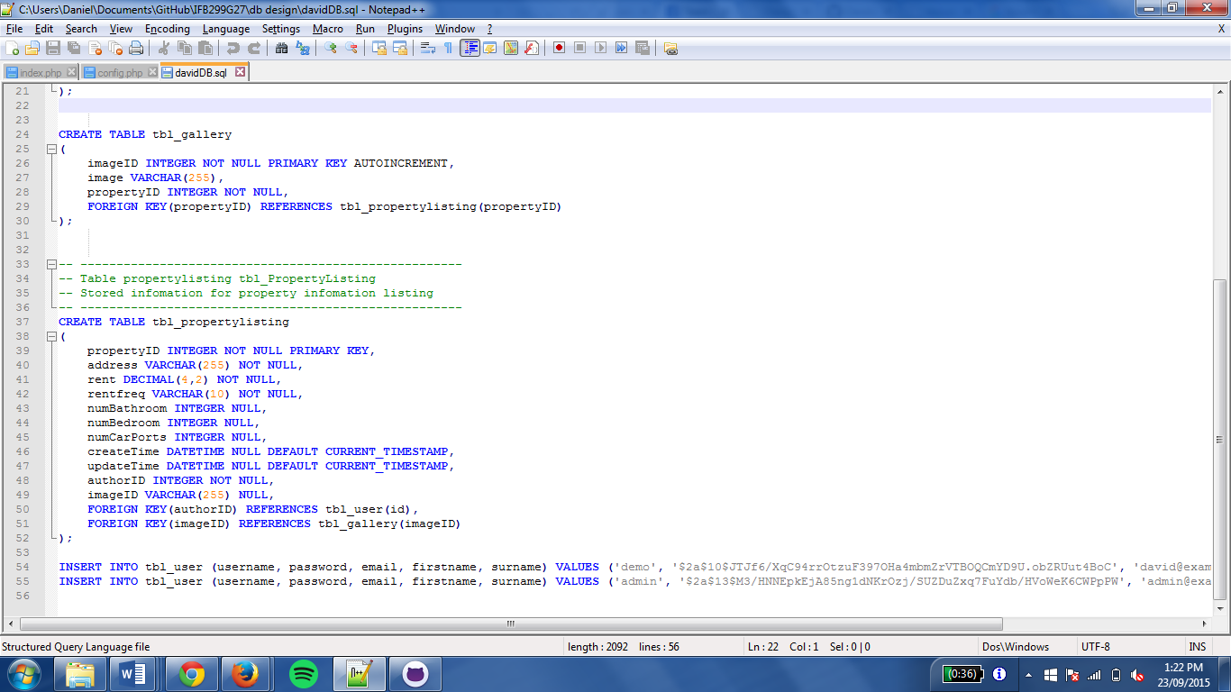

The database was completed using SQLite, and it added to the website to allow the addition of property listings on the website. This database consisted of a tbl_user, tbl_gallery and tbl_propertylisting. This ensured that the user could add information about the property including, rental price, number of bedrooms, bathrooms and the creation time of the listing.

## Artefact 5 – Created Framework

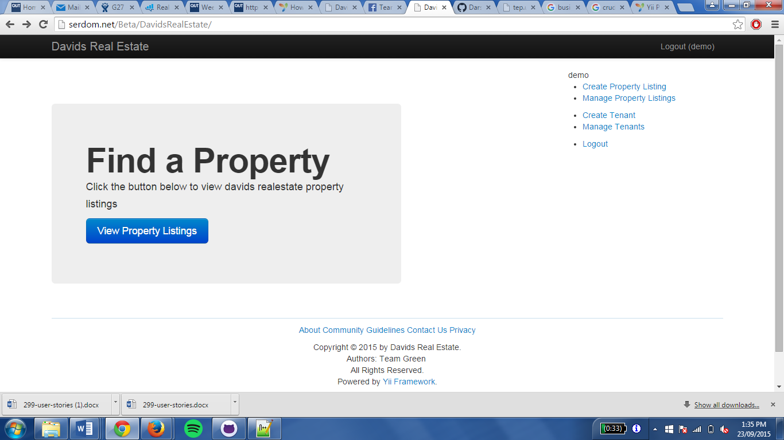

The framework for the website was created using Yii, a PHP development tool. The framework was completed in the first sprint, and set up the basic architecture for the website.